|  |
| --- |
| Fachschaft Team |
| AUTONOMOUS DRIVING CAR USER GUIDE |
| Oguzkaan Tuna, Giuseppe Scalora, Luca Brodo & Gordan Konevski |



|  |  |
| --- | --- |
|  |  |

Contents

1 General Informations 2

1.1 Introduction 3

1.1.1 Keys and parts (Hardware) 3

1.1.2 Software 3

1.2 First check 3

2 Setup your device 4

2.1 Insert SD memory Card 4

2.2 Plugin the USB cable 4

2.3 Battery check 4

2.4 Power on 5

3 Start using your GUI (Graphic user interface) 5

3.1 Automatic Mode 6

3.2 Manual Mode 6

4 Troubleshooting and Support 7

5 Products and Safety Information 8

# General Informations

This manual has been created with the purpose of delivering the informations needed in order to properly use the autonomous driving car. The main purpose of the car is the ability to autonomously drive around any kind of environment, avoiding obstacles and following a black track printed, or placed, on the floor without going off track.

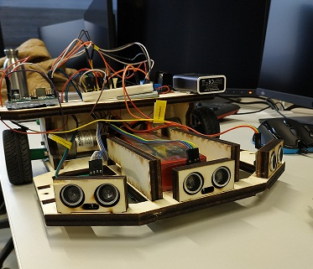

## Introduction

### Keys and parts (Hardware)

The main parts of the car can be classified as hardware parts and software parts. The main hardware parts are the sensors attached to the car, the motors, and the microcontrollers (Arduino and Raspberry Pi).

### Software

Alongside the complete car set, the proper programmes for the microcontrollers will be provided as file extensions suitable for Arduino and Raspberry Pi

## First check

Before starting to use the car, make sure that you have every component needed and listed in the components list that can be found within the set.

# Setup your device

The following steps are required to setup the hardware part of the car.

## Insert SD memory Card

In order to activate the camera functionalities of the car, it is necessary to insert the SD Card in the apposite slot on the Raspberry Pi.

## Plugin the USB cable

Make sure to plug the USB cable correctly. First connect the raspberry Pi to the 5 Volts powerbank, then connect the raspberry Pi to the arduino via the other apposite USB cable

## Battery check

Make sure that both batteries are charged (5 Volts powerbank and 12 Volts LiPo shown below). If not then use the apposite chargers.

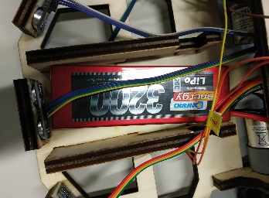

## Power on

The microcontrollers will be provided with the programme already installed therefore to turn on your car you only need to place it on the floor and press the switch placed at the back of the car frame.

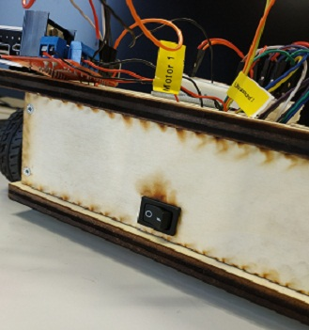

# Start using your GUI (Graphic user interface)

In addition to the autonomous functionalities of the car, it is possible to remotely control the car via an application that allows the user to manually control the car or to switch into automatic mode.

## Automatic Mode

When the car is set to automatic mode, it will start driving freely around the surrounding environment avoiding obstacles and following a black path on the floor (when it is present).

## Manual Mode

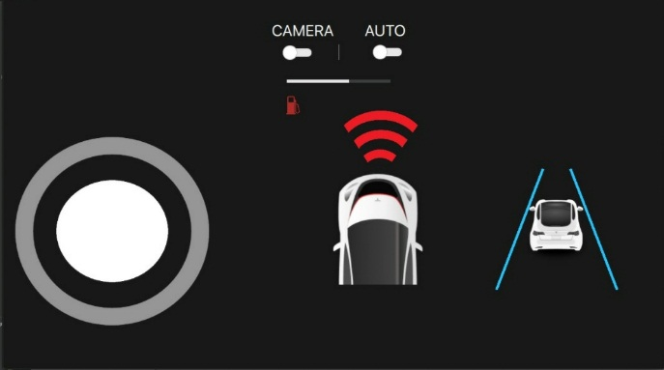When the car is set to manual mode, the user will be controlled manually via an interface (shown in the picture below)

# Troubleshooting and Support

As already stated the car will be provided with every necessary device already set up and working. Some problems may occur in regards to the batteries or the microcontrollers. As already stated, always check your battery level and check if the correct programmes are uploaded to the microcontrollers boards. In case of any other problems do not hesitate to contact us via e-mail at the following addresses:

[giuseppe.scalora@stud.hshl.de](mailto:giuseppe.scalora@stud.hshl.de)

[luca.brodo@stud.hshl.de](mailto:luca.brodo@stud.hshl.de)

[gordan.konevski@stud.hshl.de](mailto:gordan.konevski@stud.hshl.de)

[oguzkaan.tuna@stud.hshl.de](mailto:oguzkaan.tuna@stud.hshl.de)

# Products and Safety Information

Within this last chapter, it is in our interest to provide some extra safety informations for the users.

**Warnings:**

1. Do NOT touch with bare hand any possible uncovered conductor cables.
2. Make sure to keep the device away from liquid sources such as water, drinks and any possible damaging substance.
3. Do NOT leave the device in the hands of children without the supervision of an adult.
4. Do NOT swap the original batteries with others of different voltages.

ENJOY AND HAVE FUN WITH YOUR DEVICE!

*Fachschaft Team.*